操作系统实验报告
Lab 3: Programming with Threads

一、实验目的
本次实验的目的在于掌握使用nachos中的线程编程解决较为复杂的并发问题。实验内容分三部分：实现事件栅栏原语并进行正确性测试；实现闹钟原语并进行正确性测试；利用事件栅栏和闹钟原语来解决电梯问题。

二、实验要求

1、Implementing an EventBarrier Primitive
（1）事件栅栏的概念
事件栅栏（EventBarrier）是一种同步机制，使用事件栅栏可以让一组线程以同步的方式等待和应答某事件。
事件栅栏的调用者分为两类：或者调用Wait操作，或者调用Signal操作。使用事件栅栏，无论是Wait操作的调用者或者是Signal操作的调用者最终都将同步地通过栅栏（如果他们原先不同步，则进度较快的线程将通过使自己阻塞而与进度慢的线程同步）。
Wait操作的调用者在事件栅栏上等待Signal的发出。
和信号量类似，Signal操作是可以积累的——没有Waiter的Signal将被记录下来。
执行Wait操作的调用者在收到Signal后必须应答Signal的发出者——调用Complete操作表示应答结束。
只有在所有的Wait操作的调用者都已经应答后，它们才能通过事件栅栏。在所有的Wait操作的调用者都已经应答之前，Signal的发出者必须等待，并保持事件栅栏处于“SIGNALED”状态。类似地，也只有在所有的Wait操作的调用者都已经应答后，Signal的发出者才能离开事件栅栏，并恢复事件栅栏的初始状态“UNSIGNALED”。
只允许一个Signal操作的调用者发出Signal并等待应答。
（2）实现事件栅栏的几点注意
EventBarrier类的接口定义和实现应分别包含在EventBarrier.h和EventBarrier.cc中，请自己新建这些文件，并注意修改Makefile文件nachos-3.4/code/Makefile.common里的有关部分（具体项目可以参考实验一的说明）。
EventBarrier类的主要外部接口的简要说明请参考nachos-labs.pdf的3.3.1。
Signal操作的主要步骤：
设置事件栅栏的状态为SIGNALED
唤醒所有阻塞于Signal的线程
阻塞于Complete
恢复事件栅栏的状态为UNSIGNALED
Wait操作的主要步骤：
如果事件栅状态是SIGNALED，则直接返回
否则，阻塞于Signal
Complete操作的主要步骤：
如果是最后一个调用Complete者，则唤醒所有阻塞于Complete的线程
否则，阻塞于Complete
建议使用条件变量来实现（因为需要广播）

2、Implementing an Alarm Clock Primitive
用Nachos提供计时器Timer实现闹钟需要对Nachos有较深入的了解。这里的Timer是在虚拟机上模拟实现的：它的滴答不是硬件产生，而是模拟的，通常用一条指令的执行时间表示一个滴答。因此闹钟的时间也是模拟的，我们无法将这样的时间与现实世界的时间准确对应，因为模拟时间的快慢与实际硬件平台的快慢密切相关。
请仔细阅读machine/timer.h，machine/timer.cc，machine/interrupt.h，machine/interrupt.cc，threads/system.h，threads/system.cc。
Alarm类的接口定义和实现应分别包含在Alarm.h和Alarm.cc中，请自己新建这些文件，并注意修改Makefile文件nachos-3.4/code/Makefile.common里的有关部分（具体项目可以参考实验一的说明）。
Alarm必须提供某个方法，该方法由Timer的中断处理函数调用以处理闹钟时间耗尽事件。但请注意，简单地把方法的首地址作为回调函数的指针是错误的，这里涉及到对象的方法和普通函数的区别。如何处理这个问题，请参考machine/timer.cc，看看Timer是如何把间接地让interrupt处理器调用Timer中的方法。
请注意：不要试图通过修改Timer类或Interrupt类以实现Alarm；在实现Alarm时不要试图建立新的Timer对象。因为：Timer和Interrupt都是硬件设备！
另请注意，比较合理的实现是：整个系统有唯一的Alarm对象，该对象处理所有的闹铃请求。

3、Synchronization Problem 1: Bridge
你被MTA雇佣来同步公共公路上一座狭窄的轻型桥梁上的交通。车辆一次只能朝一个方向通过桥梁，如果一次桥上有超过3辆车辆，那么桥将在其重量下倒塌。在这个系统中，每辆车都由一个线程表示，当它到达桥时，线程执行过程：
OneVehicle:OneVehicle(int direc){
ArriveBridge(direc);
CrossBridge(direc);
ExitBridge(direc);}
在上面的代码中，direc是0或1：它给出了车辆通过桥梁的方向。使用您选择的任何涉及互斥体、条件变量和/或信号量的同步方案编写ArriveBridge和ExitBridge过程（CrossBridge过程应该只打印调试消息）。ArriveBridge不得返回，直到车辆能够安全地沿给定方向通过桥梁（必须保证不会发生正面碰撞或桥梁坍塌）。调用ExitBridge表示调用方已完成过桥，并应采取措施让更多车辆过桥。要测试您的程序，请创建一些车辆，这些车辆在不同方向重复使用桥接器：使用闹钟实现对车辆的非桥接器活动进行建模。你应该努力使你的解决方案公平，不致挨饿。
为了理解这涉及到什么，试着回答以下关于你的计划的问题：如果一辆车在到达时，交通正在沿着它的行驶方向穿过大桥，但另一辆车已经在等待从相反方向通过，那么新到达的车会在另一边等待的车之前通过吗，车在另一边后，还是说不出来？

4、Synchronization Problem 2: Elevator
使用线程和您选择的同步方案，包括互斥体、条件变量和/或信号量，为具有F层的建筑实现电梯控制器。您可能会发现您在这里实现的EventBarrier原语很有用。电梯控制器分为电梯和建筑两类。我们在电梯中提供了这些类的基本定义。
H定义包括两组方法：一组用于内部使用，另一组用于定义与骑手的外部接口。您需要向这些类添加新的内部方法，以允许电梯类和建筑类之间的通信，但不要修改已定义的方法的签名。使用电梯的驱动程序将首先创建一个建筑实例，然后为建筑中的每个电梯创建一个电梯对象。每个电梯都作为一个单独的线程运行。每个电梯线程都应该在电梯方法中进入一个无止境的循环，然后使用内部电梯控制接口（开门、关门、访客楼层和建筑方法）以有序的方式为乘客请求提供服务。创建建筑后，测试程序将创建一个或多个骑手，每个骑手作为单独的线程运行。
乘客使用电梯乘客界面（CallUp、CallDown、WaitUp、WaitDown、Enter、Exit、RequestFloor）向电梯及其控制器请求服务。这些方法使用电梯类和建筑类中的共享状态与控制器方法同步。您将实现这些类。注：建筑物无螺纹；它的代码仅在电梯或骑乘线程调用其方法之一时执行。第一部分。为单个电梯实施电梯控制器，包括电梯中定义的建筑和电梯方法。以及实现所需的任何新方法。您的解决方案应避免乘客饥饿以及所有明显的竞争，例如，电梯在运输过程中车门打开，车门关闭时乘客进出等。
您可以假设电梯的大小是无限的，即它可以容纳所有到达的乘客。当你的电梯停在一层时，它应该等到所有离开的乘客都已经离开，所有登机的乘客都已经登机。包括一个驾驶员测试程序，演示多个驾驶员的电梯操作。你的骑手程序应该在以下意义上“表现良好”：任何向上或向下呼叫电梯的骑手都应该立即等待，直到按请求方向行驶的电梯到达，然后上车，然后按正确的方向请求楼层，然后在正确的楼层下车。使用闹钟实现对乘客的非电梯活动进行建模。第二部分。将第1部分中的解决方案扩展到处理一次只能容纳N名乘客的电梯，其中N是编译时常量。在这种情况下，如果乘客试图在电梯满载时上车，Enter原语应返回故障状态。

三、实验流程

1、编写EventBarrier.cc，实现事件栅栏。
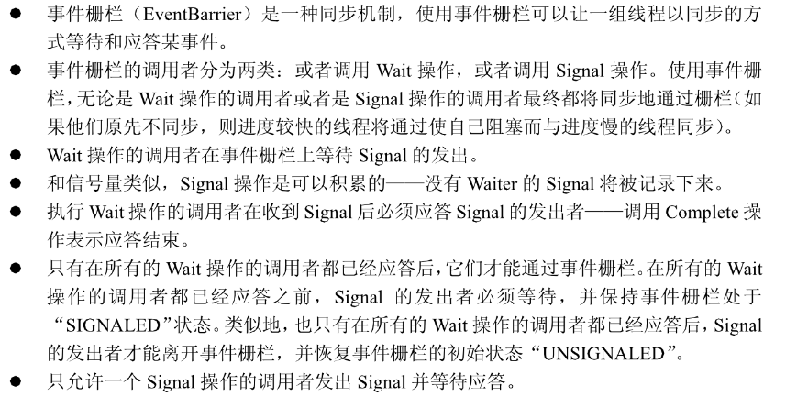

#include "EventBarrier.h"
EventBarrier::EventBarrier()
{
waiternum = 0;
lock = new Lock("EventBarrier Lock");
event = new Condition("Event come cond");
comp = new Condition("Event complete cond");
signaled = false;
}
EventBarrier::~EventBarrier()
{
delete lock;
delete event;
delete comp;
}
// 设置事件栅栏的状态为SIGNALED，唤醒所有阻塞于Signal的线程
// 阻塞于Complete，恢复事件栅栏的状态为UNSIGNALED
void EventBarrier::Signal()
{
lock->Acquire();
signaled = true;
event->Broadcast(lock);
comp->Wait(lock);
signaled = false;
//this->Wait();
//comp->Wait(lock);
lock->Release();
}
// 如果事件栅栏状态是SIGNALED，则直接返回，否则阻塞于Singal
void EventBarrier::Wait()
{
lock->Acquire();
waiternum++;
if(signaled)
{
lock->Release();
return;
}
event->Wait(lock);
lock->Release();
}
// 如果是最后一个调用Complete者，则唤醒所有阻塞于Complete的线程
// 否则，阻塞于Complete
void EventBarrier::Complete()
{
lock->Acquire();
waiternum--;
if(waiternum==0)
{
comp->Broadcast(lock);
}
else
{
comp->Wait(lock);
}
lock->Release();
}
// 返回阻塞于Complete的线程的个数
int EventBarrier::Waiters()
{
return waiternum;
}

2、编写Alarm.cc，实现闹钟原语。
#include "Alarm.h"
Alarm *Alarm::instance;
void Alarm::new_instance()
{
instance=new Alarm();
}
Alarm::Alarm()
{
queue = new DLList;
//timer = new Timer(timerhandler, 0, false);
waiters = 0;
}
Alarm::~Alarm()
{
delete queue;
//delete timer;
}
// 将事件插入中断队列，让其睡眠，等时间到了再让其进入就绪队列
void Alarm::Pause(int howLong) // howlong单位为中断次数
{
waiters++;
Thread *loop_t;
if(waiters==1)
{
loop_t = new Thread("loop thread");
loop_t->Fork(check, 0); //使至少有一个线程在运行，防止系统终止
}
IntStatus oldLevel = interrupt->SetLevel(IntOff); //必须关中断
int Ticks = TimerTicks * howLong;
queue->SortedInsert((void *)currentThread,
stats->totalTicks + Ticks); //按结束时间依序插入链表
currentThread->Sleep();
(void)interrupt->SetLevel(oldLevel);
}
void check(int which)
{
while (Alarm::instance->waiters!=0)
{
currentThread->Yield();
}
currentThread->Finish();
}
// 一个闹钟中断到来，唤醒目前应最早唤醒的线程，将其加入就绪队列
void Alarm::CheckIfDue()
{
int duetime=-1;
Thread *thread=NULL;
IntStatus oldLevel = interrupt->SetLevel(IntOff); //必须关中断
thread = (Thread *)queue->Remove(&duetime);
while (thread!= NULL)
{
if (duetime - stats->totalTicks <= 0)
{
//IntStatus oldLevel = interrupt->SetLevel(IntOff);
waiters--;
scheduler->ReadyToRun(thread);
//printf("%s wake up!\n",thread->getName()); //debug使用
thread = (Thread *)queue->Remove(&duetime);
//(void)interrupt->SetLevel(oldLevel);
}
else
{
queue->SortedInsert((void *)thread,duetime);
//printf("%d Ticks remains\n%d threads remains\n\n",
//duetime-stats->totalTicks, Alarm::instance->waiters); //debug使用
break;
}
}
(void)interrupt->SetLevel(oldLevel);
}

3、编写Bridge.cc，实现过桥问题的解决方案。
#ifdef ADV_TRAFFIC_LIGHT //改进版红绿灯算法（动态调节）
void TrafficLightManager(int whitch)
{
while (!Bridge::instance->finished)
{
Bridge::instance->lock->Acquire();
Bridge::instance->CheckIfDue();
Bridge::instance->lock->Release();
currentThread->Yield();
}
}
Bridge::Bridge()
{
lock = new Lock("bridge lock");
direc_con[0] = new Condition("direc 0 condition");
direc_con[1] = new Condition("direc 1 condition");
on_bridge_num = 0;
current_direc = 1; //默认0方向先行,由于最开始要切换一次方向，故先设成1
yellow_light_on = false;
next_switch_time = 0;
direc_car_num[0] = 0;
direc_car_num[1] = 0;
direc_car_can_go[0] = 0;
direc_car_can_go[1] = 0;
finished = false;
switchCount = 0;
manager = new Thread("traffic light manager thread");
manager->Fork(TrafficLightManager, 0);
}
Bridge::~Bridge()
{
delete lock;
delete direc_con[0];
delete direc_con[1];
}
void Bridge::ArriveBridge(int direc)
{
lock->Acquire();
direc_car_num[direc]++;
//CheckIfDue();
while (direc != current_direc || on_bridge_num >= 3 || yellow_light_on ||(direc_car_can_go[direc]<=0 && switchCount>1))
{
CheckIfDue();
direc_con[direc]->Wait(lock);
}
if(switchCount<=1)
{
direc_car_num[direc]--;
}
direc_car_can_go[direc]--;
on_bridge_num++;
lock->Release();
}
void Bridge::CrossBridge(int direc)
{
printf(">>>%s car is crossing the bridge in %d direc\n", currentThread->getName(), direc);
printf(">>>%d cars on the bridge\n\n", on_bridge_num);
Alarm::instance->Pause(CROSS_BRIDGE_TIME);
}
void Bridge::ExitBridge(int direc)
{
lock->Acquire();
on_bridge_num--;
printf("---%s car leave the bridge at %d\n", currentThread->getName(), stats->totalTicks);
direc_con[direc]->Broadcast(lock);
CheckIfDue();
lock->Release();
}
void Bridge::CheckIfDue()
{
//lock->Acquire();
if (switchCount<=1)
{
if (stats->totalTicks >= next_switch_time)
{
yellow_light_on = true;
if (on_bridge_num == 0)
{
yellow_light_on = false;
switch_status();
}
}
}
else if (direc_car_can_go[current_direc]<=0)
{
yellow_light_on = true;
if (on_bridge_num == 0)
{
yellow_light_on = false;
switch_status();
}
}
//lock->Release();
}
void Bridge::switch_status()
{
current_direc = (current_direc + 1) % 2; //切换方向
if (current_direc == 0)
{
switchCount++;
direc_car_can_go[0] = direc_car_num[0];
direc_car_can_go[1] = direc_car_num[1];
direc_car_num[0] = 0;
direc_car_num[1] = 0;
}
next_switch_time = stats->totalTicks + BASE_GREEN_LIGHT_TIME * TimerTicks;
printf("\n**********************\n");
printf("now switch the direc to %d\n",current_direc);
printf("%d cars to next switch\n",direc_car_can_go[current_direc]);
printf("0 come cars %d\t1 come cars %d", direc_car_can_go[0], direc_car_can_go[1]);
printf("\n**********************\n\n");
direc_con[current_direc]->Broadcast(lock);
}
#endif

4、编写Elevator.h文件，设定电梯容量为5人以及其他相关参数。

#pragma once
#include "EventBarrier.h"
#include "system.h"
#include "synch.h"
#define SINGLE_ELEVATOR
//#define MULTIPLE_ELEVATOR //单个或多个电梯
#define BOUNDED_ELEVATOR
//#define UNBOUNDED_ELEVATOR //电梯容量是否有限
#define OPEN_AND_CLOSE_DOOR 20 //电梯开关门的时间
#define RIDER_ENTER_OUT 10 //一个乘客进出电梯的时间
#define ELEVATOR_MOVE_ONE_FLOOR 40 //电梯移动一层楼的时间
#ifdef BOUNDED_ELEVATOR
#define ELEVATOR_CAPACITY 5 //电梯容量
#endif
enum ElevatorState {UP,DOWN,STOP};
void rider(int id, int srcFloor, int dstFloor);
class Elevator {
public:
friend class Building;
Elevator(char *debugName, int numFloors, int myID);
~Elevator();
char *getName() { return name; }
int getId(){return ElevatorID;}
// elevator control interface: called by Elevator thread
void OpenDoors(); // signal exiters and enterers to action
void CloseDoors(); // after exiters are out and enterers are in
void VisitFloor(int floor); // go to a particular floor
// elevator rider interface (part 1): called by rider threads.
bool Enter(); // get in
void Exit(); // get out (iff destinationFloor)
void RequestFloor(int floor); // tell the elevator our destinationFloor
// insert your methods here, if needed
void ElevatorControl(); //控制电梯运行
int GetLastRequestFloor();
private:
char *name;
int currentfloor; // floor where currently stopped
int occupancy; // how many riders currently onboard
// insert your data structures here, if needed
int numFloors, ElevatorID;
enum ElevatorState state;
EventBarrier **ElevatorOutBarrier; //出电梯栅栏
Lock *ElevatorLock;
Condition *HaveRequest;
#ifdef MULTIPLE_ELEVATOR
bool canEnter;
#endif
#ifdef BOUNDED_ELEVATOR
Condition *ElevatorNotFull;
#endif
};
class Building {
public:
friend class Elevator;
Building(char *debugname, int numFloors, int numElevators);
~Building();
char *getName() { return name; }
// elevator rider interface (part 2): called by rider threads
void CallUp(int fromFloor); // signal an elevator we want to go up
void CallDown(int fromFloor); // ... down
Elevator *AwaitUp(int fromFloor); // wait for elevator arrival & going up
Elevator *AwaitDown(int fromFloor); // ... down
#ifdef SINGLE_ELEVATOR
Elevator *getElevator();
#endif
#ifdef MULTIPLE_ELEVATOR
Elevator *getElevator(int id);
#endif
static void new_instance(char *debugname, int numFloors, int numElevators);
static Building *instance;
private:
char *name;
#ifdef SINGLE_ELEVATOR
Elevator *elevator; // the elevators in the building (array)
#endif
#ifdef MULTIPLE_ELEVATOR
Elevator **elevator;
#endif
EventBarrier **ElevatorUpBarrier; //上行栅栏
EventBarrier **ElevatorDownBarrier; //下行栅栏
// insert your data structures here, if needed
int numFloors;
int numElevators;
Lock *BuildingLock;
};

5、编写Elevator.cc文件，实现电梯问题解决方案
#pragma once
#include "Elevator.h"
#include "Alarm.h"
Building *Building::instance;
#ifdef SINGLE_ELEVATOR
Elevator * Building::getElevator()
{
return elevator;
}
void Building::new_instance(char *debugname, int numFloors, int numElevators)
{
instance = new Building(debugname,numFloors,numElevators);
}
Building::Building(char* debugname, int numFloors, int numElevators)
{
name = debugname;
this->numFloors = numFloors;
this->numElevators = numElevators;
elevator =new Elevator("elevator", numFloors,0);
BuildingLock = new Lock("Building lock");
ElevatorUpBarrier = new EventBarrier*[numFloors];
ElevatorDownBarrier = new EventBarrier*[numFloors];
for (int i = 0; i < numFloors; ++i)
{
ElevatorUpBarrier[i] = new EventBarrier;
ElevatorDownBarrier[i] = new EventBarrier;
}
}
Building::~Building()
{
delete elevator;
delete BuildingLock;
for (int i = 0; i < numFloors; ++i)
{
delete ElevatorUpBarrier[i];
delete ElevatorDownBarrier[i];
}
delete[] ElevatorUpBarrier;
delete[] ElevatorDownBarrier;
}
Elevator* Building::AwaitDown(int fromFloor)
{
ElevatorDownBarrier[fromFloor]->Wait();
return elevator;
}
Elevator* Building::AwaitUp(int fromFloor)
{
ElevatorUpBarrier[fromFloor]->Wait();
return elevator;
}
void Building::CallDown(int fromFloor)
{
elevator->ElevatorLock->Acquire();
elevator->HaveRequest->Signal(elevator->ElevatorLock);
elevator->ElevatorLock->Release();
}
void Building::CallUp(int fromFloor)
{
elevator->ElevatorLock->Acquire();
elevator->HaveRequest->Signal(elevator->ElevatorLock);
elevator->ElevatorLock->Release();
}
#endif //SINGLE_ELEVATOR
Elevator::Elevator(char* debugName, int numFloors, int myID)
{
name = debugName;
this->numFloors = numFloors;
ElevatorID = myID;
ElevatorOutBarrier = new EventBarrier*[numFloors];
for (int i = 0; i < numFloors; ++i)
{
ElevatorOutBarrier[i] = new EventBarrier;
}
ElevatorLock = new Lock("Elevator lock");
state = STOP;
currentfloor = 0;
HaveRequest = new Condition("have a elevator requset");
occupancy=0;
#ifdef MULTIPLE_ELEVATOR
canEnter=false;
#endif
#ifdef BOUNDED_ELEVATOR
ElevatorNotFull = new Condition("elevator is not full");
#endif
}
Elevator::~Elevator()
{
for (int i = 0; i < numFloors; ++i)
{
delete ElevatorOutBarrier[i];
}
delete[] ElevatorOutBarrier;
delete[] ElevatorLock;
delete HaveRequest;
#ifdef BOUNDED_ELEVATOR
delete ElevatorNotFull;
#endif
}
void Elevator::OpenDoors()
{
Alarm::instance->Pause(OPEN_AND_CLOSE_DOOR);
printf("\n*******now elevator %d open door at %d floor with %d riders*******\n",ElevatorID,currentfloor,occupancy);
if(ElevatorOutBarrier[currentfloor]->Waiters()!=0)
{
ElevatorOutBarrier[currentfloor]->Signal();
}
#ifdef MULTIPLE_ELEVATOR
canEnter=true;
#endif
if (state == UP)
{
if (Building::instance->ElevatorUpBarrier[currentfloor]->Waiters() != 0)
{
Building::instance->ElevatorUpBarrier[currentfloor]->Signal();
}
}
else if (state == DOWN)
{
if (Building::instance->ElevatorDownBarrier[currentfloor]->Waiters() != 0)
{
Building::instance->ElevatorDownBarrier[currentfloor]->Signal();
}
}
}
void Elevator::CloseDoors()
{
#ifdef MULTIPLE_ELEVATOR
canEnter=false;
#endif
printf("*******now elevator %d close door at %d floor with %d riders*******\n\n",ElevatorID,currentfloor,occupancy);
Alarm::instance->Pause(OPEN_AND_CLOSE_DOOR);
}
void Elevator::VisitFloor(int floor)
{
#ifdef BOUNDED_ELEVATOR
ElevatorLock->Acquire();
ElevatorNotFull->Broadcast(ElevatorLock);
ElevatorLock->Release();
#endif
Alarm::instance->Pause(ELEVATOR_MOVE_ONE_FLOOR);
currentfloor = floor;
}
bool Elevator::Enter()
{
occupancy++;
#ifdef BOUNDED_ELEVATOR
if(occupancy>ELEVATOR_CAPACITY)
{
occupancy--;
if (state == UP)
{
Building::instance->ElevatorUpBarrier[currentfloor]->Complete();
}
else if (state == DOWN)
{
Building::instance->ElevatorDownBarrier[currentfloor]->Complete();
}
ElevatorLock->Acquire();
ElevatorNotFull->Wait(ElevatorLock);
ElevatorLock->Release();
return false;
}
#endif
Alarm::instance->Pause(RIDER_ENTER_OUT);
if(state==UP)
{
Building::instance->ElevatorUpBarrier[currentfloor]->Complete();
}
else if(state==DOWN)
{
Building::instance->ElevatorDownBarrier[currentfloor]->Complete();
}
return true;
}
void Elevator::Exit()
{
Alarm::instance->Pause(RIDER_ENTER_OUT);
occupancy--;
ElevatorOutBarrier[currentfloor]->Complete();
}
void Elevator::RequestFloor(int floor)
{
ElevatorOutBarrier[floor]->Wait();
}
int Elevator::GetLastRequestFloor()
{
ElevatorLock->Acquire();
int return_value = -1;
if(state==STOP)
{
for (int i = 0; i < numFloors; ++i)
{
if (Building::instance->ElevatorUpBarrier[i]->Waiters() != 0
|| ElevatorOutBarrier[i]->Waiters() != 0
|| Building::instance->ElevatorDownBarrier[i]->Waiters() != 0)
{
return_value = i;
break;
}
}
}
else if(state==UP)
{
for (int i = numFloors - 1; i >= currentfloor; --i)
{
if (Building::instance->ElevatorDownBarrier[i]->Waiters() != 0
||ElevatorOutBarrier[i]->Waiters() != 0
||Building::instance->ElevatorUpBarrier[i]->Waiters() != 0)
{
return_value = i;
break;
}
}
}
else
{
for (int i = 0; i <= currentfloor; ++i)
{
if (Building::instance->ElevatorDownBarrier[i]->Waiters() != 0
||ElevatorOutBarrier[i]->Waiters() != 0
||Building::instance->ElevatorUpBarrier[i]->Waiters() != 0)
{
return_value = i;
break;
}
}
}
ElevatorLock->Release();
return return_value;
}
void Elevator::ElevatorControl()
{
bool no_requset_flag=false;
while (true)
{
int dest_floor = GetLastRequestFloor();
if (state==STOP)
{
ElevatorLock->Acquire();
printf("###now elevator %d stop at %d floor with %d riders\n"
,ElevatorID, currentfloor, occupancy);
if(dest_floor==-1)
{
HaveRequest->Wait(ElevatorLock);
}
ElevatorLock->Release();
printf("###now elevator %d at %d floor with %d riders\n"
,ElevatorID, currentfloor, occupancy);
dest_floor = GetLastRequestFloor();
if(dest_floor>currentfloor)
state = UP;
else
state = DOWN;
}
else if(state==UP)
{
while (currentfloor != dest_floor && dest_floor!=-1)
{
no_requset_flag = false;
if(Building::instance->ElevatorUpBarrier[currentfloor]->Waiters()!=0
||ElevatorOutBarrier[currentfloor]->Waiters()!=0)
{
OpenDoors();
CloseDoors();
}
VisitFloor(currentfloor + 1);
dest_floor = GetLastRequestFloor();
printf("###now elevator %d at %d floor with %d riders\n"
,ElevatorID, currentfloor, occupancy);
}
if(dest_floor==-1) //多个电梯时因为请求若被其他电梯满足则会被取消，故需在此处判断
{
if (no_requset_flag) //若在上一个循环中判断的另外一个方向也无请求
{
state = STOP;
continue;
}
state=DOWN;
no_requset_flag = true;
continue;
}
if(Building::instance->ElevatorUpBarrier[currentfloor]->Waiters()==0)
{
state = DOWN; //掉头
OpenDoors();
CloseDoors();
dest_floor = GetLastRequestFloor();
if(dest_floor==-1) //若DOWN方向上也无新的请求则使电梯停下
state = STOP;
else //否则向DOWN方向运行
VisitFloor(currentfloor - 1);
}
else //当所有请求中最上面的请求还是向上时
{
OpenDoors();
CloseDoors();
VisitFloor(currentfloor + 1);
}
printf("###now elevator %d at %d floor with %d riders\n"
,ElevatorID, currentfloor, occupancy);
}
else
{
while (currentfloor != dest_floor && dest_floor!=-1)
{
no_requset_flag = false;
if (Building::instance->ElevatorDownBarrier[currentfloor]->Waiters() != 0
|| ElevatorOutBarrier[currentfloor]->Waiters() != 0)
{
OpenDoors();
CloseDoors();
}
VisitFloor(currentfloor - 1);
dest_floor = GetLastRequestFloor();
printf("###now elevator %d at %d floor with %d riders\n",ElevatorID, currentfloor, occupancy);
}
if(dest_floor==-1)
{
if (no_requset_flag)
{
state = STOP;
continue;
}
state=UP;
no_requset_flag = true;
continue;
}
if(Building::instance->ElevatorDownBarrier[currentfloor]->Waiters()==0)
{
state = UP;
OpenDoors();
CloseDoors();
dest_floor = GetLastRequestFloor();
if(dest_floor==-1)
state = STOP;
else
VisitFloor(currentfloor + 1);
}
else
{
OpenDoors();
CloseDoors();
VisitFloor(currentfloor - 1);
}
printf("###now elevator %d at %d floor with %d riders\n",ElevatorID, currentfloor, occupancy);
}
currentThread->Yield();
}
}
void rider(int id, int srcFloor, int dstFloor)
{
Elevator *e;
if (srcFloor == dstFloor)
return;
printf("+++Rider %d travelling from %d to %d\n", id, srcFloor, dstFloor);
do {
if (srcFloor < dstFloor) {
printf("===Rider %d CallUp(%d)\n", id, srcFloor);
Building::instance->CallUp(srcFloor);
printf("===Rider %d AwaitUp(%d)\n\n", id, srcFloor);
e = Building::instance->AwaitUp(srcFloor);
}
else {
printf("===Rider %d CallDown(%d)\n", id, srcFloor);
Building::instance->CallDown(srcFloor);
printf("===Rider %d AwaitDown(%d)\n\n", id, srcFloor);
e = Building::instance->AwaitDown(srcFloor);
}
printf(">>>Rider %d Enter() elevator %d\n", id,e->getId());
} while (!e->Enter()); // elevator might be full!
printf(">>>Rider %d RequestFloor(%d)\n", id, dstFloor);
e->RequestFloor(dstFloor); // doesn't return until arrival
printf("---Rider %d Exit()\n", id);
e->Exit();
printf("---Rider %d finished\n", id);
}

四、测试及分析

1、EventBarrier测试。
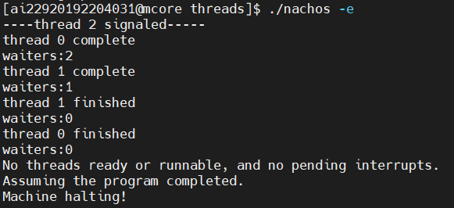
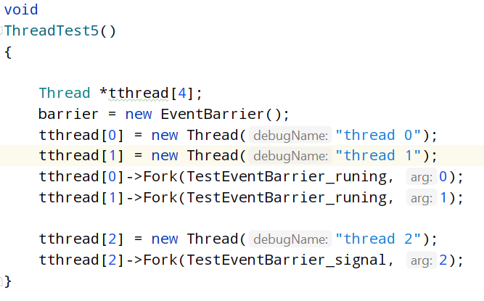
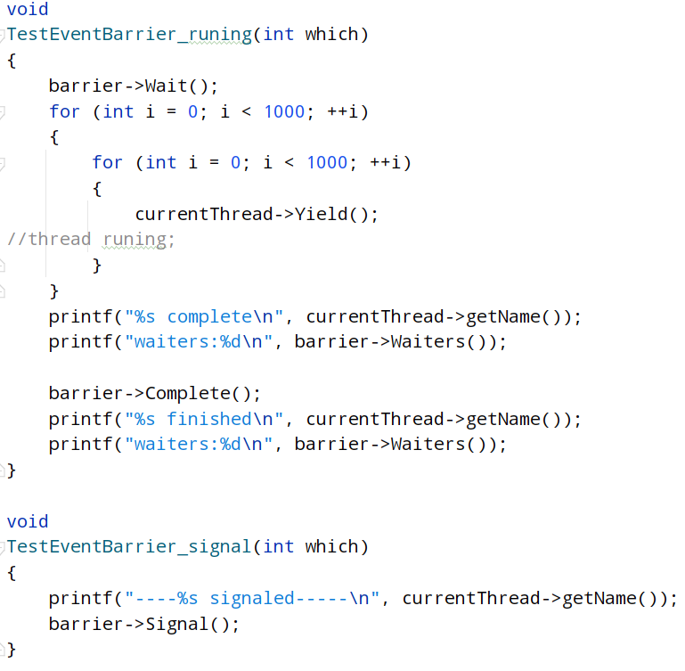

（1）初始时线程0和线程1被创建，并调用Wait()，事件栅栏初始为UNSIGHALED状态，因此两个线程加入阻塞于Signal的阻塞队列里，waiternum=2；
（2）之后线程2被创建，并调用Signal()，事件栅栏转换为SIGHALED状态，并唤醒阻塞队列里的线程0和1；事件栅栏恢复为UNSIGHALED状态；
（3）唤醒后，线程0先调用Complete()，waiternum--（不等于0），因此被阻塞于Complete的阻塞队列里；
（4）之后线程1调用Complete()，waiternum--（等于0），释放被阻塞于Complete的阻塞队列里的所有线程（此处为线程0）。

2、Alarm测试。
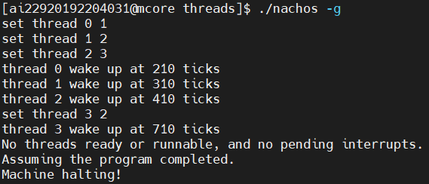
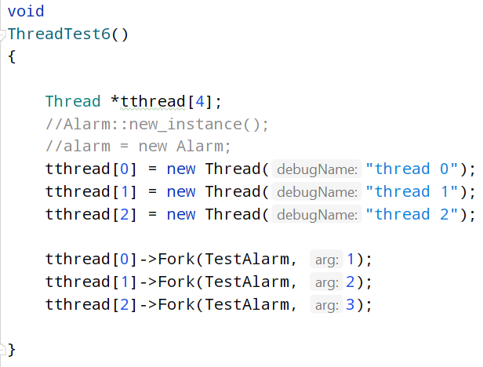
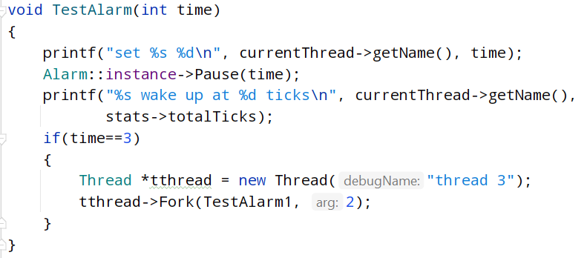
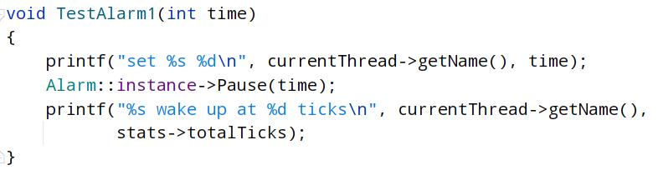
（1）初始创建3个线程，并分别设置它们在不同的时间内被唤醒，顺序依次为0、1、2 ，然后将它们置为睡眠状态，并把唤醒时间加入队列中；
（2）唤醒时间到后，将线程置为就绪状态。当线程2唤醒后，再创建一个线程3，设置闹钟中断，并使其时间到后唤醒。

3、Bridge测试。
首先给出算法：
其中，切换红绿灯的条件为（满足其一）：
（1）该方向上已经没有正在等待的车，将两个方向的灯切换为黄灯；待桥上没有车后，原方向切换为红灯，另一个方向切换为绿灯。（当切换红绿灯的次数小于1时，不进行该操作）
（2）原方向绿灯时间已到，将两个方向的灯切换为黄灯；待桥上没有车后，原方向切换为红灯，另一个方向切换为绿灯。
而车辆能否上桥的条件为（满足全部）：
（1）该方向为绿灯；
（2）桥上的车辆不多于3辆；
否则的话，车辆进入休眠状态，等待上桥。
下面展示10辆车的情况输出：
[ai22920192204031@mcore threads]$ ./nachos -h 10  **********************  now switch the direc to 0  0 cars to next switch  0 come cars 0 1 come cars 0  **********************  +++car 0 start at 530 ticks in 0 direction  >>>car 0 car is crossing the bridge in 0 direc  >>>1 cars on the bridge  +++car 1 start at 1120 ticks in 1 direction  ---car 0 car leave the bridge at 1660  ---car 0 costs 1160  +++car 2 start at 1940 ticks in 0 direction  >>>car 2 car is crossing the bridge in 0 direc  >>>1 cars on the bridge  +++car 3 start at 2460 ticks in 1 direction  +++car 4 start at 2760 ticks in 1 direction  ---car 2 car leave the bridge at 3060  ---car 2 costs 1150  **********************  now switch the direc to 1  0 cars to next switch  0 come cars -2 1 come cars 0  **********************  >>>car 1 car is crossing the bridge in 1 direc  >>>1 cars on the bridge  >>>car 3 car is crossing the bridge in 1 direc  >>>2 cars on the bridge  >>>car 4 car is crossing the bridge in 1 direc  >>>3 cars on the bridge  +++car 5 start at 3400 ticks in 1 direction  +++car 6 start at 3860 ticks in 0 direction  +++car 7 start at 4040 ticks in 1 direction  ---car 1 car leave the bridge at 4340  ---car 1 costs 3270  >>>car 5 car is crossing the bridge in 1 direc  >>>3 cars on the bridge  ---car 3 car leave the bridge at 4570  ---car 3 costs 2150  ---car 4 car leave the bridge at 4630  ---car 4 costs 1900  >>>car 7 car is crossing the bridge in 1 direc  >>>2 cars on the bridge  +++car 8 start at 4960 ticks in 0 direction  +++car 9 start at 5070 ticks in 1 direction  >>>car 9 car is crossing the bridge in 1 direc  >>>3 cars on the bridge  ---car 5 car leave the bridge at 5550  ---car 5 costs 2180  ---car 7 car leave the bridge at 5840  ---car 7 costs 1830  ---car 9 car leave the bridge at 6250  **********************  now switch the direc to 0  2 cars to next switch  0 come cars 2 1 come cars 0  **********************  ---car 9 costs 1230  >>>car 6 car is crossing the bridge in 0 direc  >>>1 cars on the bridge  >>>car 8 car is crossing the bridge in 0 direc  >>>2 cars on the bridge  ---car 6 car leave the bridge at 7560  ---car 6 costs 3730  ---car 8 car leave the bridge at 7610  **********************  now switch the direc to 1  0 cars to next switch  0 come cars 0 1 come cars 0  **********************  ---car 8 costs 2680  ------avg turnaround time 2128.00------ | 方向0绿灯，方向1红灯  等待：无  桥上：c0(d0)  等待：c1(d1)  桥上：无  等待：c1(d1)  桥上：c2(d0)  等待：c1(d1), c3(d1)  等待：c1(d1), c3(d1), c4(d1)  桥上：无  方向0红灯，方向1绿灯  等待：无  桥上：c1(d1) , c3(d1), c4(d1)  等待：c5(d1)  等待：c5(d1), c6(d0)  等待：c5(d1), c6(d0), c7(d1)  桥上：c3(d1), c4(d1)  等待：c6(d0), c7(d1)  桥上：c3(d1), c4(d1), c5(d1)  桥上：c4(d1), c5(d1)  桥上：c5(d1)  等待：c6(d0)  桥上：c5(d1), c7(d1)  等待：c6(d0), c8(d0)  桥上：c5(d1), c7(d1)  桥上：c5(d1), c7(d1), c9(d1)  桥上： c7(d1), c9(d1)  桥上： c9(d1)  桥上： 无  方向0绿灯，方向1红灯  等待：c8(d0)  桥上：c6(d0)  等待：无  桥上：c6(d0), c8(d0)  桥上：c8(d0)  桥上：无  方向0红灯，方向1绿灯  完成

4、Elevator测试。
（1）设定：20个乘客，5层楼，乘客到达电梯的时间为随机生成。下面是乘客的初始化：

[ai22920192204031@mcore threads]$ ./nachos -i
###now elevator 0 stop at 0 floor with 0 riders

+++rider 0 start at 540 ticks from 3 floor to 1 floor
+++Rider 0 travelling from 3 to 1
===Rider 0 CallDown(3)
===Rider 0 AwaitDown(3)

###now elevator 0 at 0 floor with 0 riders

+++rider 1 start at 740 ticks from 0 floor to 3 floor
+++Rider 1 travelling from 0 to 3
===Rider 1 CallUp(0)
===Rider 1 AwaitUp(0)

+++rider 2 start at 840 ticks from 1 floor to 2 floor
+++Rider 2 travelling from 1 to 2
===Rider 2 CallUp(1)
===Rider 2 AwaitUp(1)

+++rider 3 start at 980 ticks from 1 floor to 2 floor
+++Rider 3 travelling from 1 to 2
===Rider 3 CallUp(1)
===Rider 3 AwaitUp(1)

+++rider 4 start at 1080 ticks from 0 floor to 4 floor
+++Rider 4 travelling from 0 to 4
===Rider 4 CallUp(0)
===Rider 4 AwaitUp(0)

+++rider 5 start at 1170 ticks from 1 floor to 0 floor
+++Rider 5 travelling from 1 to 0
===Rider 5 CallDown(1)
===Rider 5 AwaitDown(1)

+++rider 6 start at 1260 ticks from 2 floor to 1 floor
+++Rider 6 travelling from 2 to 1
===Rider 6 CallDown(2)
===Rider 6 AwaitDown(2)

+++rider 7 start at 1360 ticks from 3 floor to 2 floor
+++Rider 7 travelling from 3 to 2
===Rider 7 CallDown(3)
===Rider 7 AwaitDown(3)

+++rider 8 start at 1450 ticks from 2 floor to 0 floor
+++Rider 8 travelling from 2 to 0
===Rider 8 CallDown(2)
===Rider 8 AwaitDown(2)

+++rider 9 start at 1540 ticks from 3 floor to 2 floor
+++Rider 9 travelling from 3 to 2
===Rider 9 CallDown(3)
===Rider 9 AwaitDown(3)

+++rider 10 start at 1630 ticks from 4 floor to 2 floor
+++Rider 10 travelling from 4 to 2
===Rider 10 CallDown(4)
===Rider 10 AwaitDown(4)

+++rider 11 start at 1730 ticks from 3 floor to 4 floor
+++Rider 11 travelling from 3 to 4
===Rider 11 CallUp(3)
===Rider 11 AwaitUp(3)

+++rider 12 start at 1820 ticks from 3 floor to 1 floor
+++Rider 12 travelling from 3 to 1
===Rider 12 CallDown(3)
===Rider 12 AwaitDown(3)

+++rider 13 start at 1910 ticks from 2 floor to 4 floor
+++Rider 13 travelling from 2 to 4
===Rider 13 CallUp(2)
===Rider 13 AwaitUp(2)

+++rider 14 start at 2000 ticks from 1 floor to 4 floor
+++Rider 14 travelling from 1 to 4
===Rider 14 CallUp(1)
===Rider 14 AwaitUp(1)

+++rider 15 start at 2090 ticks from 2 floor to 3 floor
+++Rider 15 travelling from 2 to 3
===Rider 15 CallUp(2)
===Rider 15 AwaitUp(2)

+++rider 16 start at 2180 ticks from 3 floor to 1 floor
+++Rider 16 travelling from 3 to 1
===Rider 16 CallDown(3)
===Rider 16 AwaitDown(3)

+++rider 17 start at 2280 ticks from 0 floor to 1 floor
+++Rider 17 travelling from 0 to 1
===Rider 17 CallUp(0)
===Rider 17 AwaitUp(0)

+++rider 18 start at 2370 ticks from 2 floor to 0 floor
+++Rider 18 travelling from 2 to 0
===Rider 18 CallDown(2)
===Rider 18 AwaitDown(2)

+++rider 19 start at 2460 ticks from 1 floor to 0 floor
+++Rider 19 travelling from 1 to 0
===Rider 19 CallDown(1)
===Rider 19 AwaitDown(1)

可以用表格来展示乘客的信息：
乘客 | 所在楼层 | 目标楼层 | 按电梯键 | 按键时间
0 | 3 | 1 | 下 | 540
1 | 0 | 3 | 上 | 740
2 | 1 | 2 | 上 | 840
3 | 1 | 2 | 上 | 980
4 | 0 | 4 | 上 | 1080
5 | 1 | 0 | 下 | 1170
6 | 2 | 1 | 下 | 1260
7 | 3 | 2 | 下 | 1360
8 | 2 | 0 | 下 | 1450
9 | 3 | 2 | 下 | 1540
10 | 4 | 2 | 下 | 1630
11 | 3 | 4 | 上 | 1730
12 | 3 | 1 | 下 | 1820
13 | 2 | 4 | 上 | 1910
14 | 1 | 4 | 上 | 2000
15 | 2 | 3 | 上 | 2090
16 | 3 | 1 | 下 | 2180
17 | 0 | 1 | 上 | 2280
18 | 2 | 0 | 下 | 2370
19 | 1 | 0 | 下 | 2460

（2）电梯从第0层开始运行，运行结果如下：

*******now elevator 0 open door at 0 floor with 0 riders*******
>>>Rider 1 Enter() elevator 0
>>>Rider 4 Enter() elevator 0
>>>Rider 17 Enter() elevator 0
>>>Rider 17 RequestFloor(1)
*******now elevator 0 close door at 0 floor with 3 riders*******

>>>Rider 1 RequestFloor(3)
>>>Rider 4 RequestFloor(4)
###now elevator 0 at 1 floor with 3 riders

*******now elevator 0 open door at 1 floor with 3 riders*******
---Rider 17 Exit()
---Rider 17 finished
------rider 17 costs 11680------
>>>Rider 2 Enter() elevator 0
>>>Rider 3 Enter() elevator 0
>>>Rider 14 Enter() elevator 0
>>>Rider 14 RequestFloor(4)
*******now elevator 0 close door at 1 floor with 5 riders*******

>>>Rider 2 RequestFloor(2)
>>>Rider 3 RequestFloor(2)
###now elevator 0 at 2 floor with 5 riders

*******now elevator 0 open door at 2 floor with 5 riders*******
---Rider 2 Exit()
---Rider 3 Exit()
---Rider 3 finished
------rider 3 costs 24040------
---Rider 2 finished
------rider 2 costs 24340------
>>>Rider 13 Enter() elevator 0
>>>Rider 15 Enter() elevator 0
>>>Rider 15 RequestFloor(3)
*******now elevator 0 close door at 2 floor with 5 riders*******

>>>Rider 13 RequestFloor(4)
###now elevator 0 at 3 floor with 5 riders

*******now elevator 0 open door at 3 floor with 5 riders*******
---Rider 1 Exit()
---Rider 15 Exit()
---Rider 15 finished
------rider 15 costs 34030------
---Rider 1 finished
------rider 1 costs 35530------
>>>Rider 11 Enter() elevator 0
>>>Rider 11 RequestFloor(4)
*******now elevator 0 close door at 3 floor with 4 riders*******

###now elevator 0 at 4 floor with 4 riders

*******now elevator 0 open door at 4 floor with 4 riders*******
---Rider 4 Exit()
---Rider 14 Exit()
---Rider 13 Exit()
---Rider 11 Exit()
---Rider 11 finished
------rider 11 costs 45520------
---Rider 4 finished
------rider 4 costs 46320------
---Rider 14 finished
------rider 14 costs 45450------
---Rider 13 finished
------rider 13 costs 45590------
>>>Rider 10 Enter() elevator 0
>>>Rider 10 RequestFloor(2)
*******now elevator 0 close door at 4 floor with 1 riders*******

###now elevator 0 at 3 floor with 1 riders

*******now elevator 0 open door at 3 floor with 1 riders*******
>>>Rider 0 Enter() elevator 0
>>>Rider 7 Enter() elevator 0
>>>Rider 9 Enter() elevator 0
>>>Rider 12 Enter() elevator 0
>>>Rider 16 Enter() elevator 0
>>>Rider 12 RequestFloor(1)
*******now elevator 0 close door at 3 floor with 5 riders*******

>>>Rider 0 RequestFloor(1)
>>>Rider 7 RequestFloor(2)
>>>Rider 9 RequestFloor(2)
===Rider 16 CallDown(3)
===Rider 16 AwaitDown(3)

###now elevator 0 at 2 floor with 5 riders

*******now elevator 0 open door at 2 floor with 5 riders*******
---Rider 10 Exit()
---Rider 7 Exit()
---Rider 9 Exit()
---Rider 9 finished
------rider 9 costs 66750------
---Rider 10 finished
------rider 10 costs 66830------
---Rider 7 finished
------rider 7 costs 67150------
>>>Rider 6 Enter() elevator 0
>>>Rider 8 Enter() elevator 0
>>>Rider 18 Enter() elevator 0
>>>Rider 18 RequestFloor(0)
*******now elevator 0 close door at 2 floor with 5 riders*******

>>>Rider 6 RequestFloor(1)
>>>Rider 8 RequestFloor(0)
###now elevator 0 at 1 floor with 5 riders

*******now elevator 0 open door at 1 floor with 5 riders*******
---Rider 12 Exit()
---Rider 0 Exit()
---Rider 6 Exit()
---Rider 6 finished
------rider 6 costs 78330------
---Rider 12 finished
------rider 12 costs 77930------
---Rider 0 finished
------rider 0 costs 79260------
>>>Rider 5 Enter() elevator 0
>>>Rider 19 Enter() elevator 0
>>>Rider 19 RequestFloor(0)
*******now elevator 0 close door at 1 floor with 4 riders*******

>>>Rider 5 RequestFloor(0)
###now elevator 0 at 0 floor with 4 riders

*******now elevator 0 open door at 0 floor with 4 riders*******
---Rider 18 Exit()
---Rider 8 Exit()
---Rider 19 Exit()
---Rider 5 Exit()
---Rider 5 finished
------rider 5 costs 89680------
*******now elevator 0 close door at 0 floor with 0 riders*******

---Rider 18 finished
------rider 18 costs 88590------
---Rider 8 finished
------rider 8 costs 89560------
---Rider 19 finished
------rider 19 costs 88600------
###now elevator 0 at 1 floor with 0 riders
###now elevator 0 at 2 floor with 0 riders
###now elevator 0 at 3 floor with 0 riders

*******now elevator 0 open door at 3 floor with 0 riders*******
>>>Rider 16 Enter() elevator 0
>>>Rider 16 RequestFloor(1)
*******now elevator 0 close door at 3 floor with 1 riders*******

###now elevator 0 at 2 floor with 1 riders
###now elevator 0 at 1 floor with 1 riders

*******now elevator 0 open door at 1 floor with 1 riders*******
---Rider 16 Exit()
---Rider 16 finished
------rider 16 costs 120380------

-------avg turnaround time 61278.00-------
-------max turnaround time 120380-------
-------min turnaround time 11680-------

*******now elevator 0 close door at 1 floor with 0 riders*******

###now elevator 0 at 1 floor with 0 riders
###now elevator 0 stop at 1 floor with 0 riders
No threads ready or runnable, and no pending interrupts.
Assuming the program completed.
Machine halting!

流程如下：
电梯所在楼层 | 在电梯的人 | 出电梯的人 | 电梯方向
0 | 1(3)、4(4)、17(1) |  | 上
1 | 1(3)、4(4)、2(2)、3(2)、14(4) | 17 | 上
2 | 1(3)、4(4)、14(4)、13(4)、15(3) | 2、3 | 上
3 | 4(4)、14(4)、13(4)、11(4) | 1、15 | 上
4 | 10(2) | 4、14、13、11 | 下
3 | 10(2)、0(1)、7(2)、9(2)、12(1)  注：16无法进电梯，故电梯走后，他又在3楼按了下键 |  | 下
2 | 0(1)、12(1)、6(1)、8(0)、18(0) | 10、7、9 | 下
1 | 8(0)、18(0)、5(0)、19(0) | 0、12、6 | 下
0 |  | 8、18、5、19 | 上
3 | 16(1) |  | 下
1 |  | 16

该算法的流程图如下：

五、实验总结
1、事件栅栏是用于某线程在进行某些操作前需要某个事件或条件先得到满足后再执行的情况下使用。
2、闹钟原语可以实现让线程进入睡眠并在特定时间后被唤醒。将线程的唤醒时间加入队列中，不停地循环检查，时间到之后，将队列中的第一个线程移除并置为就绪态。
3、Bridge问题类似于数据单项传输问题，且每次传输的大小受到限制。可以使用动态红绿灯算法，在绿灯时间到后，切换两个方向的红绿灯状态，达到分流作用，这样不会导致一个方向上等候的车辆过多。动态的优点在于，如果一个方向上，绿灯时间未到但车辆已经全部通过，可以直接切换红绿灯状态，但是要注意必须经过一次红绿灯切换之后才能进行动态控制。
4、Elevator问题是目前最难的的算法。我没有实现人员动态到达电梯并按下按钮，而是所有人都到达电梯并按下按钮后才开始启动电梯运载。但是运载的算法是比较合规的，电梯每移动一层，就检查电梯内是否有乘客到达了目的层，如果有就开门让到达的乘客出去；之后检查电梯外是否有该方向的乘客，如果有就开门让乘客依次进电梯，直至满载。如果满载，剩下的乘客在电梯离开后重新按按钮。电梯离开后按当前方向上或下一层，到达顶楼或底楼后转换方向。

六、实验心得
本次实验是操作系统最后一次实验，难度比较大，特别是电梯算法，比较遗憾的是最后都没有完整实现，只能实现当乘客全部就绪时电梯开始才运行。通过此次实验，我对事件栅栏、闹钟原语的理解更加深刻，并学会运用它们解决一些问题。

